OIL CONDITION MONITORING REPORT SLNS VIJAYABAHU

GENERATOR PARTCULARS (Information provided by the customer)
 | SSDG (Port)
Make : | Electro-Motive Division
Model : | 8-645E6
Sr.No’s: | 70-H1-1044
Date sampling : | 01 Aug 25 | 04 Aug 25
Sampling point : | Lub oil sump
Sampling Method : | Extraction
Type of Lubricant : | Shell Gadinia S3 SAE 40
System Capacity : | 250 US gal

RUNNING HRS DETAILS (Information provided by the customer)
 | SSDG (Port)
Sample ID | M010555 | M010556
Oil Running Hours | - | 04.00
Total Running Hours of the Machinery | 137,939.00 | 137,943.00

ANALYSIS RESULTS

Description | Method | Uncertainty  (K=2) | Fresh Oil  (As per the provided fresh oil sample) | SSDG (Port)
 |  |  |  | S/I-M010555 | S/I-M010556
Viscosity @ 40ºC(cSt) | ASTM D 445 | 0.006 | 128.00 | 128.13 | 128.07
Viscosity @ 100ºC (cSt) | ASTM D 445 | 0.005 | 13.70 | 13.77 | 13.80
Viscosity Index | ASTM D 2270 | N/A | 103 | 103.84 | 104.33
Total Base No. mg KOH/g | ASTM D 4739 | 0.77 | 10.48* | 9.85 | 9.80
Flash Point (cº) | ASTM D 92 | 0.026 | 230 | 228 | 228
Water content % | ASTM D 95 | 0.082 | < 0.2 | <0.1 | <0.1
* Results were extracted from a fresh oil sample tested at MTTU laboratory as per ASTM D 4739 method.
Elemental Concentration as per ASTM D5185 (ppm)

Element | Maximum Permissible Limit | Fresh Oil  Sample | Uncertainty  (K=2) | SSDG (Port)
 |  |  |  | S/I-M010555 | S/I-M010556
Fe | 80 | < 1.000 | 0.15 | N/C | 3.804
Cr | 10 | < 1.000 | 0.18 | N/C | < 1.000
Si | 15 | < 1.000 | 0.17 | N/C | < 1.000
Al | 20 | < 1.000 | 0.28 | N/C | 1.050
Pb | 20 | < 1.000 | 0.13 | N/C | 1.413
Cu | 25 | < 1.000 | 0.17 | N/C | 1.358
Sn | 10 | < 1.000 | 0.20 | N/C | < 1.000
Ni | 10 | < 1.000 | 0.08 | N/C | < 1.000

TREND ANALYSIS WITH PREVIOUS REPORT

 |  |  | Fresh Oil Sample |  |  | SSDG (Port)
 |  |  |  |  |  | S/I-M005482 | S/I- M00571 | S/I- M00574 | S/I- M00590 | S/I- M00596 | S/I- M00599 | S/I- M00606 | S/I-M00611 | S/I-M006173 | S/I- M006248 | S/I-M006378 | S/I-M006512 | S/I- M006529 | S/I- M006598
Oil Running Hrs |  |  | - |  |  | 1001.26 | 1546.0 | 1787.5 | 2139.52 | 2456. | 2706. | 2956 | 3089.39 | 3206.29 | 3437.72 | 3687.32 | 3937.00 | 4187.00 | 4270.31
T/R/H of Machinery |  |  | - |  |  | 129046 | 129591 | 129833 | 130185 | 130501 | 130751 | 131001 | 131135 | 131251.54 | 131483.12 | 131733.12 | 131983.12 | 132233.12 | 132324.71
Viscosity @ 40ºC (cSt) |  |  | 131.49* |  |  | 122.44 | 132.49 | 131.43 | 129.82 | 131.73 | 132.03 | 132.04 | 131.05 | 132.11 | 131.02 | 134.38 | 133.42 | 126.95 | 124.04
Viscosity @ 100ºC (cSt) |  |  | 14.52* |  |  | 13.37 | 13.95 | 13.80 | 13.74 | 13.96 | 14.01 | 14.02 | 14.09 | 14.01 | 13.68 | 13.78 | 14.11 | 13.50 | 13.34
Viscosity Index |  |  | 110.25 |  |  | 104.19 | 102.01 | 101.09 | 101.80 | 102.88 | 103.21 | 103.33 | 105.18 | 103.14 | 104.91. | 98.31 | 103.20 | 104.25 | 102.13
Total Base No (mgKOH/g) |  |  | 9.02* |  |  | 9.36 | N/C | 9.98 | N/C | N/C | N/C | N/C | N/C | N/C | N/C | N/C | N/C | N/C | N/C
Flash Point (ºC) |  |  | 220* |  |  | 190 | N/C | 190 | N/C | N/C | N/C | N/C | N/C | N/C | N/C | N/C | N/C | N/C | N/C
Water content (%) |  |  | <0.2 |  |  | <0.1 | N/C | <0.1 | N/C | N/C | N/C | N/C | N/C | N/C | N/C | N/C | N/C | N/C | N/C
 |  | Elemental Concentration as per ASTM D5185 (ppm)
Element | Max.  Permissible
Fe | 80 |  |  | < 1.000 |  | 10.283 | 7.076 | 6.562 | 5.177 | 5.005 | 1.415 | 9.994 | 7.059 | 8.150 | 2.526 | 5.534 | 15.937 | 6.584 | 4.867
Cr | 10 |  |  | < 1.000 |  | < 1.000 | < 1.000 | < 1.000 | < 1.000 | < 1.000 | < 1.000 | < 1.000 | < 1.000 | < 1.000 | < 1.000 | < 1.000 | < 1.000 | < 1.000 | < 1.000
Si | 15 |  |  | < 1.000 |  | 7.549 | 5.833 | 10.671 | 6.998 | 3.733 | < 1.000 | 12.203 | 5.240 | 5.915 | 2.045 | 4.877 | 14.034 | 4.291 | 3.810
Al | 20 |  |  | < 1.000 |  | 1.806 | 3.386 | 3.513 | < 1.000 | < 1.000 | < 1.000 | 9.787 | 2.912 | 9.103 | 2.500 | 2.233 | 11.284 | 1.699 | 2.043
Pb | 20 |  |  | < 1.000 |  | 6.754 | 13.156 | 6.453 | 19.800 | 11.966 | 10.332 | 15.275 | 10.734 | 4.175 | 5.413 | 3.481 | 4.178 | 4.185 | 3.25
Cu | 25 |  |  | < 1.000 |  | 10.371 | 12.737 | 1.067 | 14.809 | 15.757 | 13.437 | 15.546 | 9.717 | 16.762 | 12.789 | 13.296 | 15.678 | 15.720 | 14.096
Sn | 10 |  |  | < 1.000 |  | 2.606 | 2.928 | <1.000 | 2.721 | 2.856 | 3.242 | 3.628 | 3.009 | 3.794 | < 1.000 | 2.023 | < 1.000 | < 1.000 | 3.2
Ni | 10 |  |  | < 1.000 |  | < 1.000 | N/C | N/C | N/C | N/C | N/C | < 1.000 | < 1.000 | < 1.000 | N/C | N/C | < 1.000 | < 1.000 | < 1.000
 |  | Fresh Oil Sample | SSDG (Port)
 |  | Fresh Oil Sample | S/I- M006709 | M006781 |  | S/I- M006882 | S/I- M006991 | S/I- M007107 | S/I- M007233 | S/I- M007439 | S/I- M007517 | S/I-  M007834 | S/I-  M008075 | Fresh Oil Sample | S/I-  M008213 | S/I-  M008259 | S/I-  M008492 | S/I-  M008505 | S/I-  M008605 | S/I-  M008764 | S/I-  M008806 | S/I-  M008967 | S/I-  M009196 | S/I-  M009217
Oil Running Hrs |  | - | 4520.31 | 4770.20 |  | 5012.20 | 5226.55 | 5,491.35 | 5741.35 | 5991.35 | 6241.35 | 6491.35 | 6741.35 | - | 6991.35 | 7,258.45 | 7508.45 | 7758.45 | 7991.35 | 8241.35 | 8429.40 | 8679.40 | 8679.40 | 9179.40
T/R/H of Machinery |  | - | 132574.71 | 132,824.40 |  | 133066.40 | 133281.15 | 133,531.15 | 13378.15 | 134031.15 | 134281.15 | 134531.15 | 134781.15 | - | 135,031.15 | 135,281.15 | 135,531.15 | 135,781.15 | 136031.15 | 136281.15 | 136469.20 | 136,719.20 | 136969.20 | 137,219.20
Viscosity @ 40oC (cSt) |  | 131.49* | 131.48 | 129.27 |  | 132.66 | 129.50 | 130.72 | 134.42 | 132.49 | 129.14 | 127.36 | 130.26 | 128.00 | 135.36 | 123.22 | 132.98 | 133.07 | 131.94 | 130.59 | 133.83 | 131.24 | 132.43 | 131.80
Viscosity @ 100oC (cSt) |  | 14.52* | 14.00 | 13.38 |  | 13.04 | 13.66 | 13.88 | 14.37 | 14.09 | 13.54 | 13.73 | 13.56 | 13.70 | 14.39 | 13.27 | 13.87 | 13.26 | 13.20 | 13.40 | 14.39 | 13.95 | 14.08 | 13.70
Viscosity Index |  | 110.25* | 103.63 | 97.82 |  | 90.43 | 101.08 | 102.80 | 105.52 | 103.81 | 99.85 | 104.10 | 99.151 | 103 | 104.89 | 101.98 | 100.55 | 93.013 | 93.20 | 96.93 | 106.32 | 103.19 | 103.753 | 99.48
Total Base No. mgKOH/g |  | 9.02* | N/C | N/C |  | N/C | 9.30 | 9.03 | 8.94 | 8.79 | 8.42 | 8.10 | 7.90 | 10.48* | 6.73 | 6.88 | 6.76 | 6.68 | 6.84 | 6.95 | 7.10 | 7.28 | 7.26 | 7.19
Flash Point (oC) |  | 220* | N/C | N/C |  | N/C | 200 | 190 | 190 | 190 | 190 | 190 | 192 | 230 | 218 | 214 | 218 | 216 | 214 | 214 | 216 | 218 | 218 | 216
Water content% |  | < 0.2* | N/C | N/C |  | N/C | < 0.1 | < 0.1 | <0.1 | <0.1 | <0.1 | <0.1 | < 0.1 | < 0.2 | < 0.1 | < 0.1 | < 0.1 | < 0.1 | < 0.1 | < 0.1 | < 0.1 | <0.1 | <0.1 | <0.1
Elemental Concentration as per ASTM D5185 (ppm)
Element | Max. Permissible  Limit
Fe | 80 | < 1.000 | 6.076 |  | 11.925 | 10.030 | 8.263 | 8.149 | 7.555 | 7.425 | 9.038 | 10.18 | 5.470 | < 1.000 | 11.122 | 12.137 | 9.610 | 7.703 | 8.591 | 13.258 | 7.130 | 7.058 | 6.906 | 7.671
Cr | 10 | < 1.000 | < 1.000 |  | < 1.000 | < 1.000 | < 1.000 | < 1.000 | 1.149 | 1.399 | < 1.000 | 1.425 | 1.159 | < 1.000 | 1.577 | 1.387 | < 1.000 | < 1.000 | < 1.000 | 1.979 | < 1.000 | < 1.000 | 1.207 | < 1.000
Si | 15 | < 1.000 | 5.664 |  | 14.652 | 10.531 | 8.201 | 5.027 | 3.556 | 3.874 | 6.188 | 7.683 | 1.453 | < 1.000 | 5.595 | 6.871 | 3.725 | 3.449 | 4.549 | 4.136 | 1.121 | 6.465 | < 1.000 | < 1.000
Al | 20 | < 1.000 | 2.723 |  | 6.398 | 3.350 | 3.607 | < 1.000 | < 1.000 | < 1.000 | 1.322 | 1.476 | <1.000 | < 1.000 | 1.589 | 1.540 | < 1.000 | < 1.000 | < 1.000 | 2.442 | 1.000 | 1.277 | < 1.000 | < 1.000
Pb | 20 | < 1.000 | 5.259 |  | 4.710 | 6.539 | 4.818 | 4.619 | 4.173 | 3.938 | 4.528 | 4.586 | 3.563 | < 1.000 | 4.708 | 5.370 | 4.902 | 3.839 | 4.089 | 2.424 | 3.723 | 3.831 | 3.922 | 4.160
Cu | 25 | < 1.000 | 14.656 |  | 19.659 | 17.955 | 18.122 | 13.425 | 20.103 | 15.290 | 17.731 | 17.222 | 10.817 | < 1.000 | 18.984 | 22.194 | 22.025 | 17.653 | 19.136 | 9.070 | 15.309 | 16.225 | 16.492 | 15.399
Sn | 10 | < 1.000 | 3.539 |  | 4.401 | 4.822 | 4.603 | 3.542 | 3.102 | 2.689 | 3.676 | 3.441 | 2.451 | < 1.000 | 4.509 | 5.162 | 5.465 | 4.358 | 4.568 | 2.476 | 3.636 | 4.219 | 4.299 | 4.570
Ni | 10 | < 1.000 | N/A |  | < 1.000 | < 1.000 | < 1.000 | < 1.000 | < 1.000 | < 1.000 | <1.000 | <1.000 | N/C | < 1.000 | < 1.000 | < 1.000 | < 1.000 | < 1.000 | < 1.000 | < 1.000 | < 1.000 | < 1.000 | < 1.000 | < 1.000

 |  | SSDG (Port)
 |  | Fresh Oil Sample | S/I- M009300 | S/I-  M009521 | S/I-  M009849 | S/I-  M010555 | S/I-  M010556
Oil Running Hrs |  |  | 9,429.40 | 9,679.40 | 9,771.45 | - | 04.00
T/R/H of Machinery |  |  | 137,469.20 | 137,719.20 | 137,811.25 | 137,939.00 | 137,943.00
Viscosity @ 40ºC (cSt) |  | 128.00 | 130.50 | 131.59 | 130.49 | 128.13 | 128.07
Viscosity @ 100ºC (cSt) |  | 13.7 | 13.77 | 14.27 | 14.01 | 13.77 | 13.80
Viscosity Index |  | 103 | 101.58 | 106.96 | 104.69 | 130.87 | 104.33
Total Base No. mgKOH/g |  | 10.48* | 7.32 | 7.30 | 7.10 | 9.85 | 9.80
Water content% |  | < 0.2 | < 0.1 | <0.1 | <0.1 | 228 | 228
Flash Point (oC) |  | 230 | 214 | 214 | 212 | <0.1 | <0.1
Elemental Concentration as per ASTM D5185 (ppm)
Element | Max. Permissible Limit
Fe | 80 | < 1.000 | 6.346 | 7.770 | 6.167 | N/C | 3.804
Cr | 10 | < 1.000 | 1.234 | 1.361 | < 1.000 | N/C | < 1.000
Si | 15 | < 1.000 | < 1.000 | < 1.000 | 2.322 | N/C | < 1.000
Al | 20 | < 1.000 | 1.058 | 3.542 | < 1.000 | N/C | 1.050
Pb | 20 | < 1.000 | 4.226 | 4.190 | 4.889 | N/C | 1.413
Cu | 25 | < 1.000 | 15.639 | 20.382 | 16.595 | N/C | 1.358
Sn | 10 | < 1.000 | 3.918 | 4.160 | 4.259 | N/C | < 1.000
Ni | 10 | < 1.000 | < 1.000 | < 1.000 | < 1.000 | N/C | < 1.000

Wear Metals

SSDG (Port)
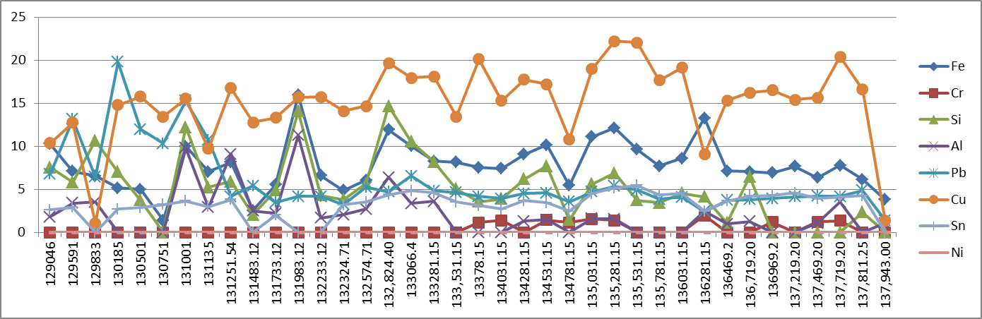

ppm

Element | Maximum Permissible Limit
Fe | 80
Cr | 10
Si | 15
Al | 20
Pb | 20
Cu | 25
Sn | 10
Ni | 10

Total Running Hrs

Viscosity

SSDG (Port)
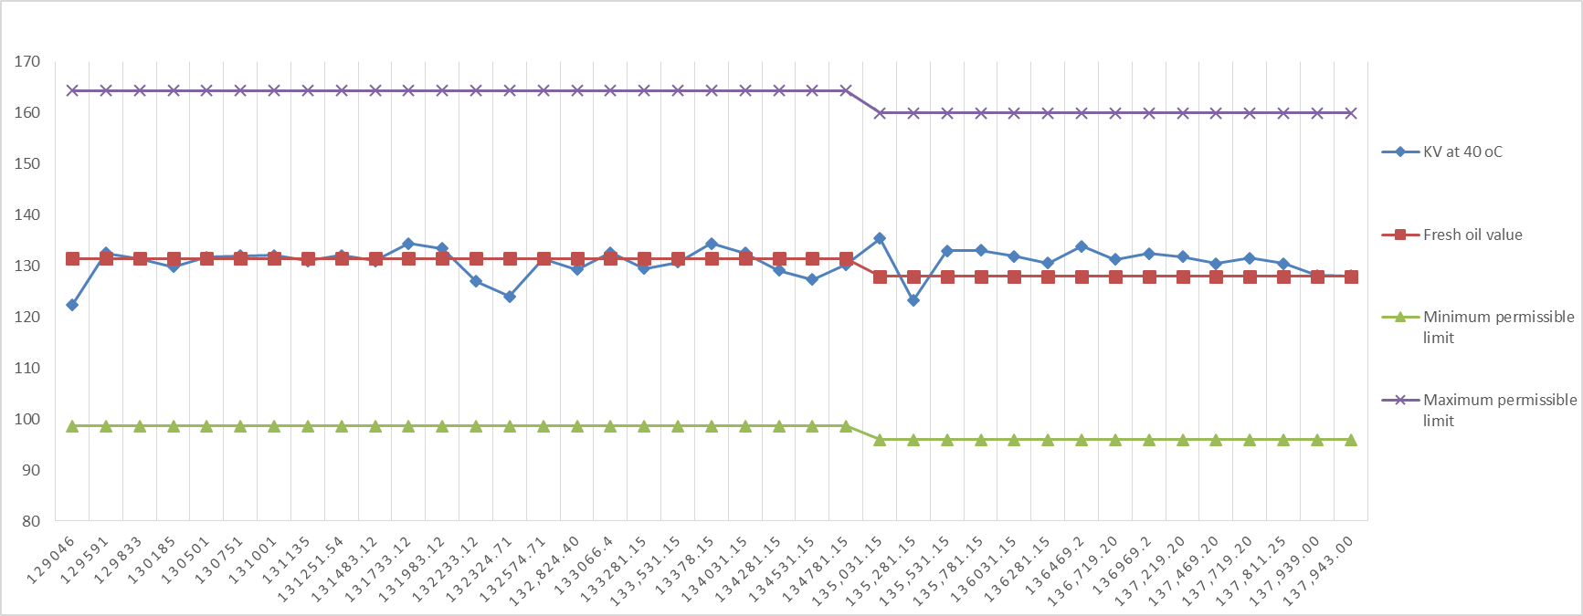
At 40⁰C

cSt

Total Running hrs

Maximum permissible limit of Shell Gadinia S3 SAE 40 at 40ºC | 160 cSt
Shell Gadinia S3 SAE 40 fresh oil viscosity value at 40ºC | 128 cSt
Minimum permissible limit of Shell Gadinia S3 SAE 40 at 40ºC | 96 cSt

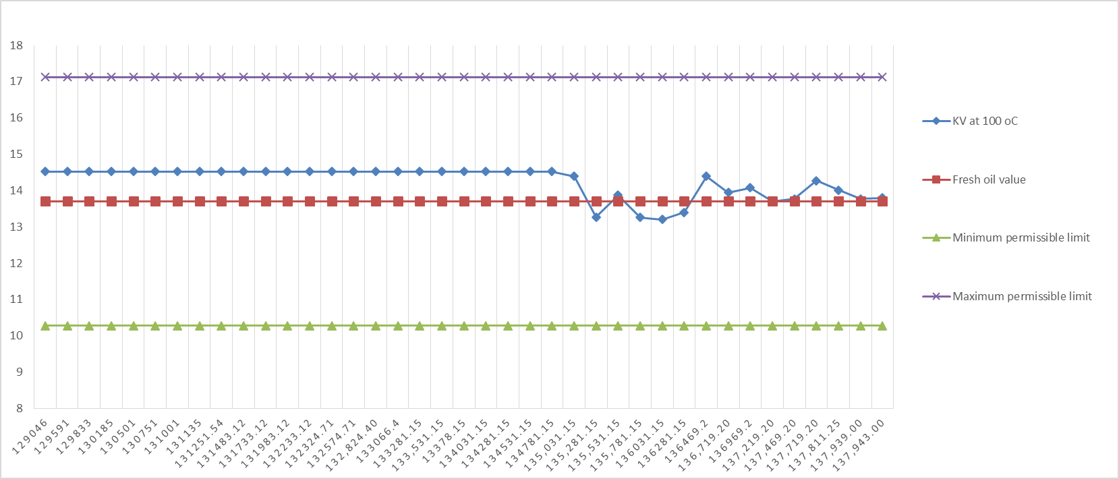
At 100⁰C

cSt

Total Running hrs
Maximum permissible limit of Shell Gadinia S3 SAE 40 at 100ºC | 17.125 cSt
Shell Gadinia S3 SAE 40 fresh oil viscosity value at 100ºC | 13.70 cSt
Minimum permissible limit of Shell Gadinia S3 SAE 40 at 100ºC | 10.275 cSt

